- User Story to Tests by JIRA Integration:

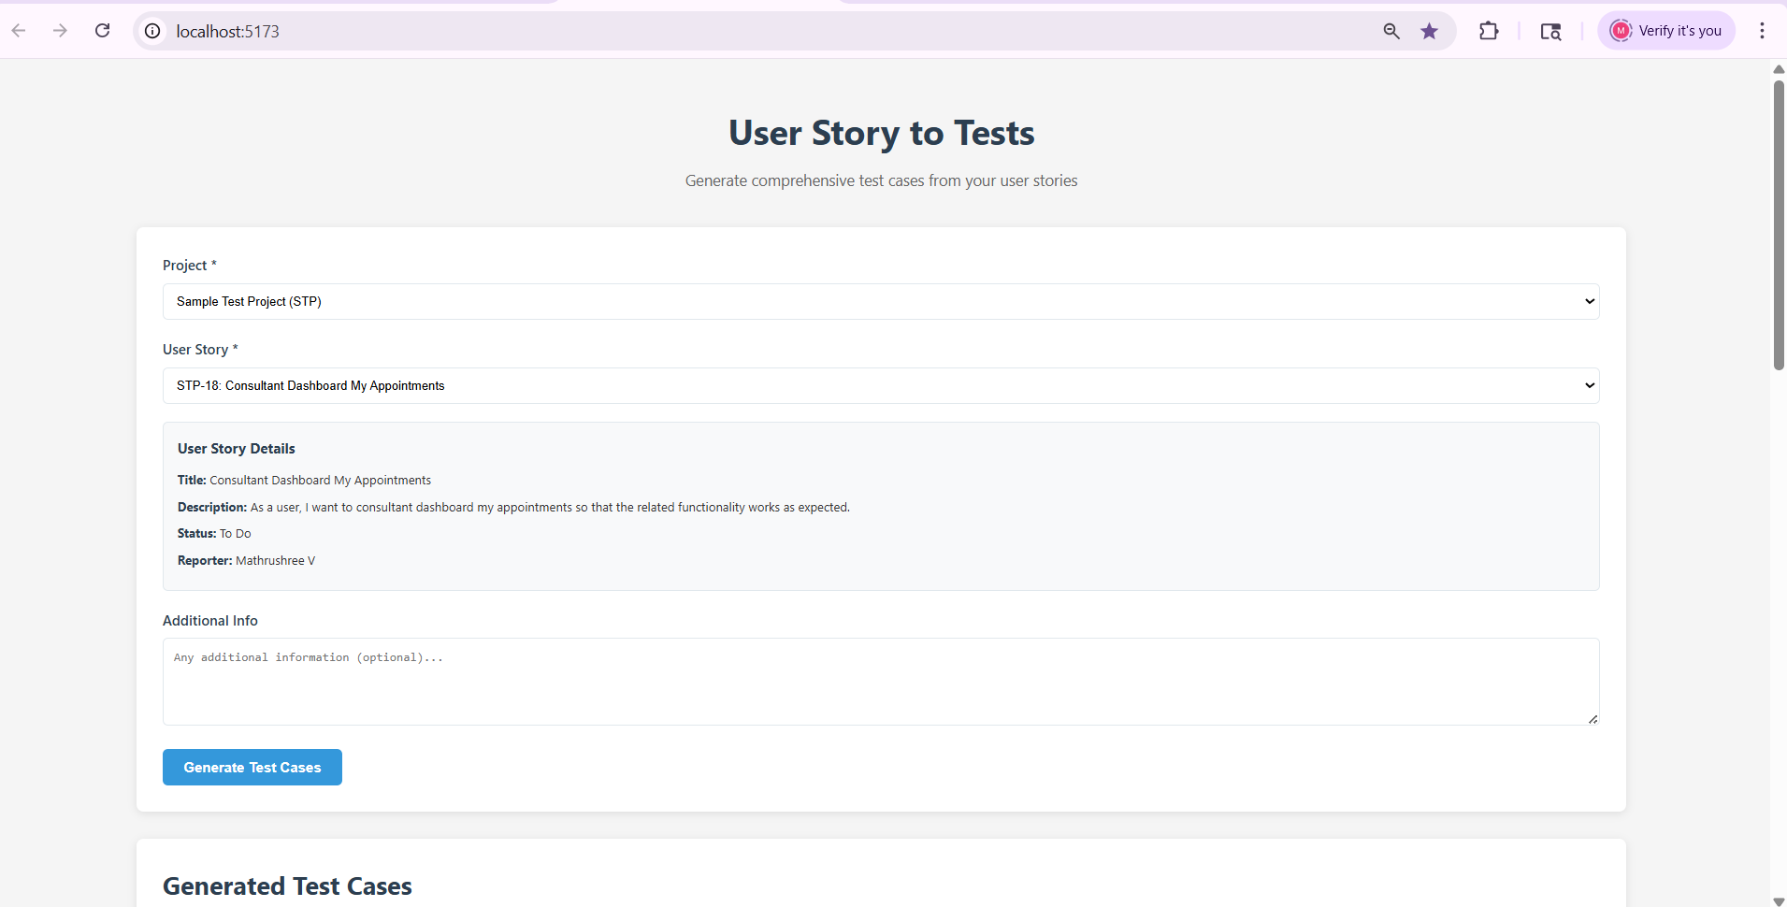

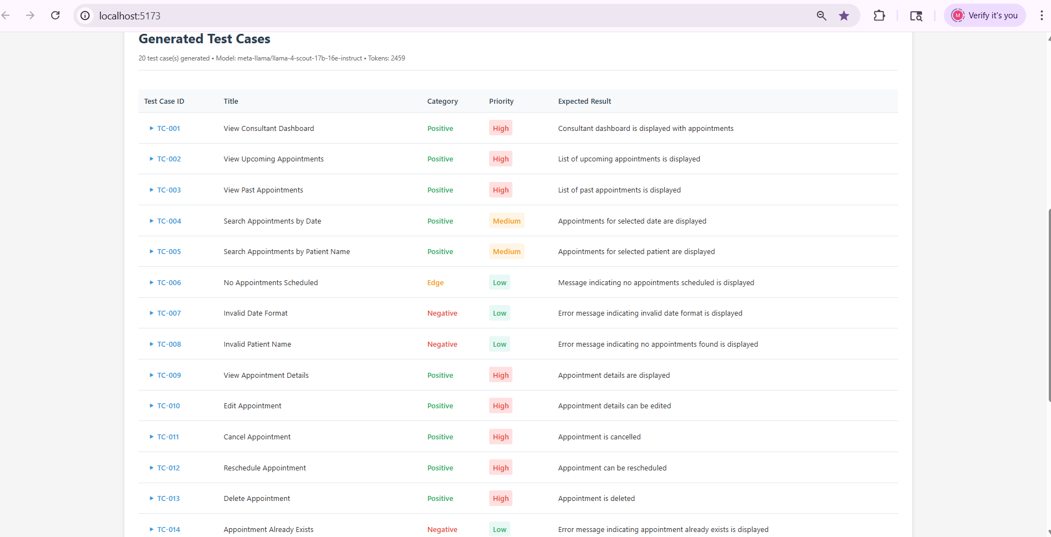

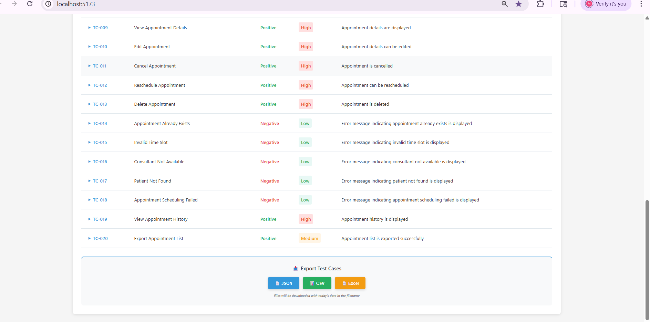

Analzye my existing code base and Implement Jira integration

GO STEP BY STEP up on my approval proceed with next step

[Mandatory] implement Backend first then proceed with Frontend

Instruction

[MANDATORY] Implement Jira connectivity email,api key should be configurable in .env file
[CRITICAL] Fetch the Projects from Jira (Projects should be autopopulated as dropdown that is user should be able to select project from the dropdown on the UI)
[CRITICAL] Fetch User stories for the project (user stories should be autpopulated as dropdown user should be able to select user stories from the dropdown on the UI)

REFER MY POSTMAN COLLECTION :

- AI browser extension-generate code for Playwright with typescript
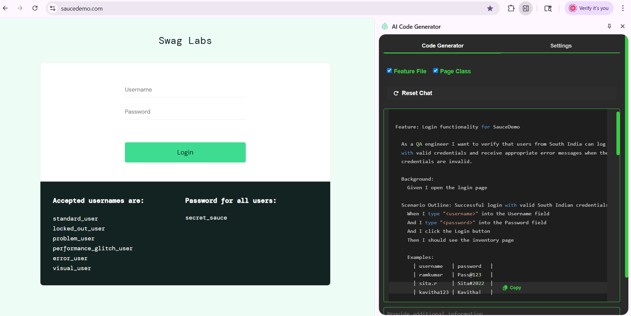
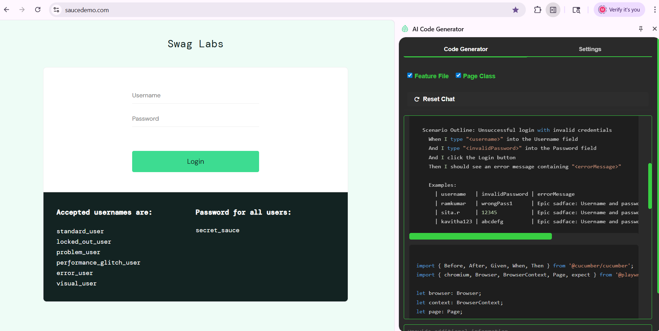

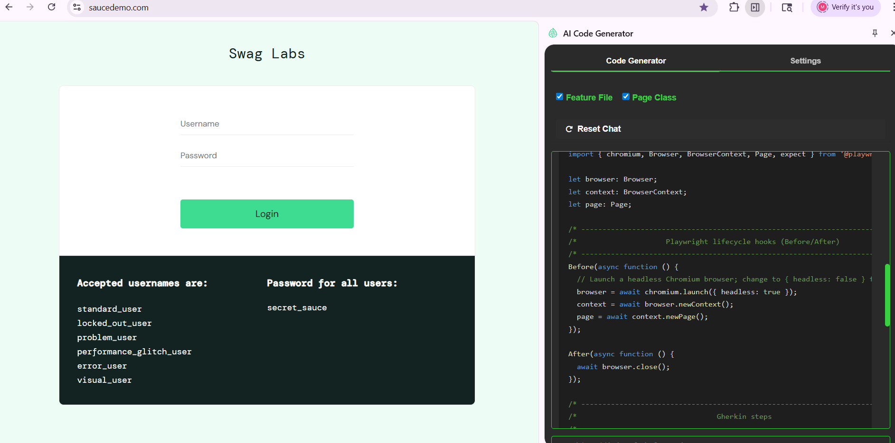

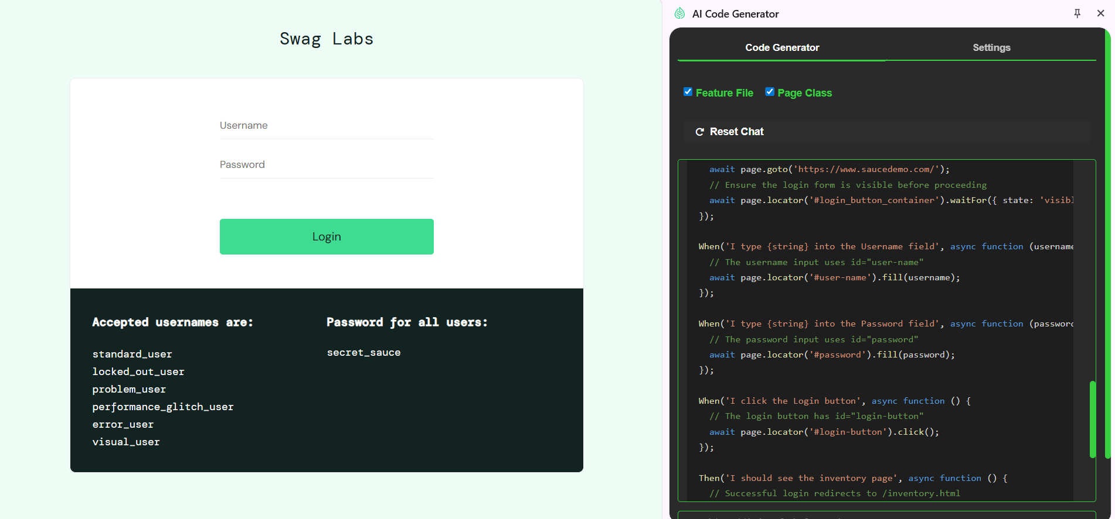

Analyze my entire code base for Selenium Java(Feature File, Page Class, Feature File + Page Class)

After Analyzing this
Go Step by Step, once up on my approval proceed with next step

Give me files in which implementation is done
Proceed with Playwright Typescript implementation

